Ideas for Writing Vision and Mission Statements
A vision statement describes how the world would look if you completed your mission.

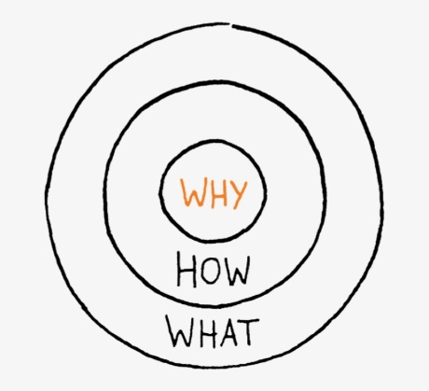
The importance of both mission and vision statements starts with the “Why.” In his book Start with Why, Simon Sinek shares his concept of the Golden Circle: Every person knows what they do; some people know how they do it. But few people know why they do it. The “Why” is the purpose and the driving factor of our work. Instead of focusing on the outer circle, we need to start from the center and move outwards with regards to our mission and vision statements. Explain why you want to do what you do, then how you will do it (mission), and finally what end goal you are aiming to achieve(vision).

VISION defines what the organization wants to become or achieve
- Is forward looking, a picture of the “preferred future”
- Is aspirational and inspirational
- Describes how the world will be different if you succeed
- Often it describes not just the future of the organization, but the future of the industry or society in which the organization hopes to effect change.

Rape Crisis Center Vision
Our vision is the elimination of sexual violence.

Breakthrough School Vision
Further Greater Cleveland’s transformation by providing distinctive school options to thousands of Cleveland's K-8 students.

MISSION defines the purpose of the organization
- Is meaningful to the organization, including employees, donors, etc
- Includes an action, target audience, and outcome
- Should be ‘durable’ but revisited every so often to tweak as needed

Rape Crisis Center Mission
Cleveland Rape Crisis Center supports survivors of rape and sexual abuse, promotes healing and prevention and advocates for social change.

Breakthrough Schools Mission
The Mission of Breakthrough Schools is to develop a growing network of distinctive school options that prepare Cleveland area students for success in life.

Questions to ask for a Vision Statement
- Without revealing how, what is our organization working to accomplish?

- What is the dream for this organization?

- How will people live differently if our organization is successful?

- If you could achieve anything with your work, what would that look like?

- What words or phrases depict the type of organization and end-goals we want?

Questions to Ask for Mission Statement
- What are the primary functions and activities that your business performs?

- What makes your business different from everyone else?

- What is the result of the work your organization does?

- Why does your organization do what it does?

- For whom does the business conduct activities?

- What makes your business different from everyone else?

