How to Write an Effective Call to Action

What is a Call to Action?
A “Call to Action” is a short phrase that tells the reader what action you want them to take and how to take it. These should be 1 -5 words with a hyperlink or clickable button.

Calls to Actions should be included in almost all Social Media Posts because a reader usually will not take action unless they are asked. There is a lot of noise and reader move on to the next thing rather quickly. In order to get them to stop and take the action you want them to take you need to ask them.

Use the FAB Model
As with all copywriting on social media make sure a post the accompanies a Call to Action has the FAB included. Features, Advantages and Benefits.

Here is an example

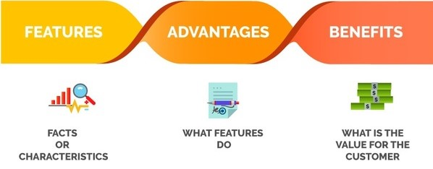
“Optimize your Facebook Ads as Easily as Making your Morning Coffee”

Discover Why Here

Feature – “Optimize your Facebook Ads”
Advantage – “as Easily”
Benefit – “as Making your Morning Coffee”
Create a Reason to Take Action
Tell your audience what is in it for them by tying in your value proposition. Provide Incentives that motivate the audience. Introduce benefits and incentives to take action, instead of just the instructions.
You want to be really specific with the action words you choose and the instructions that follow them.
Template for Posts with CTA
Help us _____________by_________________ or ____________________
Discover Why Here

Donate to our ______________to help _______________
Learn More

Tired of not getting __________try____________________
Get Started
Examples of Common Calls to Action
Try
Watch
Get Started
Learn More
Discover More

Other Words to Use When Writing Calls to Actions and Posts on Social Media

Most persuasive words in the English Language
Instantly
More
Because
Free
How To
You

Persuasive Words that appeal toward what someone values
Ultimate
Discover
Announcing
Latest

Persuasive Words that represent giving someone an advantage
Premium
Standout
Limited
Exclusive

Persuasive Words that reassure
Lifetime
Certified
Powerful
Secure
Proven
Results
Easy
Now
Today
Find Better

